Southern Tier Chapter of
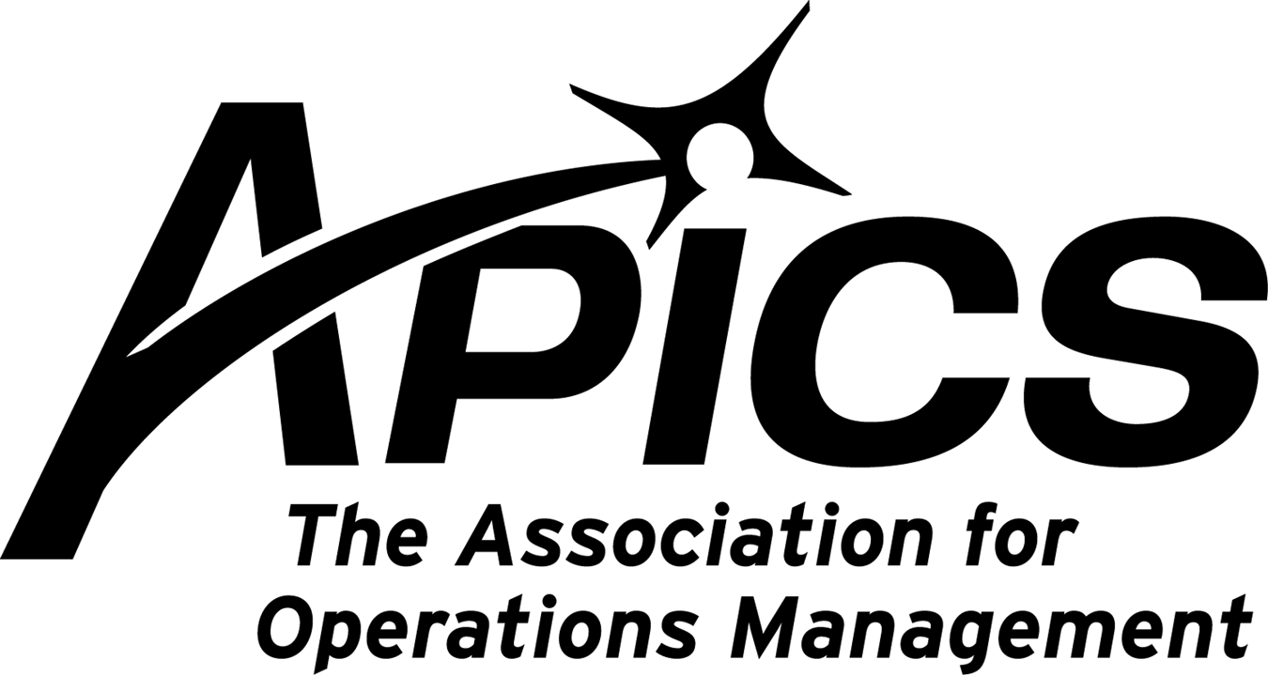
www.stapics.org

“Advancing productivity and innovation and competitive success.”

APICS & NAPM DINNER MEETING

Thursday, February 17, 2010

Location: Relief Pitcher
197 Conklin Ave. Binghamton, NY

Guest Speaker:
Phil Jordan, Psychic Extraordinaire

5:30PM Sign-in and Networking
6:00PM Dinner (Family Style)
7:00PM Guest Speaker

Cost: $25.00

RSVP by February 14th to Keith_Jamba@uhs.org or by calling 607-763-5138

Thanks and hope to see you there!

FEBRUARY DINNER MEETING SPEAKER BIO:

Phil Jordan:

Phil Jordan is always a big hit and has made many accurate predictions and readings to our group. You won’t want to miss this!! All friends and family are welcome, come and join the fun.

Phil Jordan has become a name synonymous with psychic phenomenon. He graduated Corning Community College in 1970 with an AAS in Humanities and Social Services, and then attended SUNY Brockport where he graduated in 1972 with a BA in Secondary Education, majoring in high school Spanish. In 1975, he successfully led a search team to the location o f a missing boy by using a map he envisioned the night before.

Shortly after, he was sworn in as a Deputy by the Tioga County Sheriff and graduated from the NYS Municipal Police Training
Academy. He has worked with police agencies in all levels of government, including cases of missing persons, homicide, and arson. His investigative skills and unusual abilities have earned him respect throughout the police agencies he has worked with.

He has also taught seminars and courses in the use of psychics and hypnosis in criminal investigation. Phil has taught at various colleges and universities, as well as hosting his own radio shows for several years. He has appeared as a guest on many talk shows and was highlighted in a segment of news oriented broadcast prepared by the BBC. He was ordained in 1988 as a Nondenominational Interfaith Minister, and is Pastor in Charge of the Caroline Center Church in Caroline Center, NY. His spirituality and personality are a tribute to the continually growing parish family, and for Phil, his ministry is a dream come true. Phil graduated from the prestigious Simmons School of Funeral Service in Syracuse, NY in 1988 and passed the requirements to be licensed as a NYS Funeral Director in 1989. He established the Candor Funeral Parlor Inc. in Candor, NY in 1985. In 1990, Phil completed his requirements for a MS in Education from Elmira College. His thesis work was in the role of funeral services in the grief process. He has published a book that expounds on his life’s experiences. Phil Jordan’s personality and humor, as well as his knowledge in his professions, contributes to a most delightful and enlightening experience.

APICS News from Don Sheldon, Vice President of Education

Re-Certification – This is a rerun of a previous offer. To date we have had only a couple people interested. An outstanding offer is currently being made from APICS for people whose certification has lapsed. The opportunity is limited so you must react soon.

The Southern Tier APICS Chapter is proposing a study group led by a Master Trainer (Either Dave Gardner or me) to do readiness training for the recertification exam. It will be scheduled once we have a roster of interested students. We are entertaining 4 afternoons (16 hours total-probably 2-6pm each session) to review materials from study notes. We will also do practice questions similar to what might be on the exam.

The Cost will be $250 plus the book cost. We will use the 2010 APICS CPIM Exam Content Manual which can be downloaded with qualification approval by APICS for free (see http://www.apics.org/Certification/RecertificationExam.htm) and Brian Willcox Study Notes series also from APICS ($147).

If you are interested in this study class, please contact me at dsheldon@sheldoninc.com. If we get enough to sign up, we will run it. Thanks!

ECO (Execution and Control of Operations) – The Southern Tier Chapter is offering the ECO Class starting in January to be held at Broome Community College. This is the 4th in the CPIM series of five readiness courses for the certification process. There are seats available presently. The class will be from 2:30 – 6:30 starting Monday 10 January. I will be leading this course.

The Cost will be $375 plus the book cost. You will need to purchase the ECO Student workbook or we can order it for you. The cost of the book ordered from the Southern Tier Chapter will be $85.

Member Cost Non-Member Cost
Class $375.00 $375.00
Workbook (required) $85.00 $85.00
1 year membership $200.00
Total $460.00 $660.00

If you are interested in this class, please contact me at dsheldon@sheldoninc.com. Thanks!

CSCP-Certification – Also we will be offering the CSCP (certified supply chain professional) readiness course in the spring. CSCP is APICS’s newest certification program. The cost for this 12 session course will be $825 plus book (which is $800) for Members and $1075 plus book (which is $800) for non-members which will include membership. I will be the instructor. I have a couple people already signed up and we will probably be starting it in April when the ECO course is finished. We will be running this course regardless of interest per BOD decision last fall.

If you are interested in this study class, please contact me at dsheldon@sheldoninc.com. Thanks!

Don Sheldon
Vice President Education – Southern Tier Chapter
International Chair BOK



We’re on !!!

Come and visit, poke around, or comment on us! Our name there is “Southern Tier Apics”. It’s just another way
for us to keep in touch with our membership.

For the latest in chapter happenings check out WWW.STAPICS.ORG

Your 2010-2011 Board of Directors

President / VP Education Dave Gardner dgardner@akraturn.com
VP Membership / Website Lee Schechter lschechter@stny.rr.com
Executive VP / Director of Finance Steve Whited steve.whited@mwv.com
Director of Education Don Sheldon dsheldon@stny.rr.com
Publicity / Marketing / Programming Michael LoSapio Michael.losapio@synergyresources.net
Marketing Director Kelly Norieka Kelly.norieka@lmco.com
Secretary Deb Unkel deb.unkel@raymondcorp.com

Southern Tier APICS
PO Box 1107
Binghamton NY 13902-1107

